**Application Description:**

A simple online File Conversion application is used to convert

* .doc/.docx files to .pdf files
* .pdf to .doc/.docx files and
* .pdf to .txt files.

The application backend code is written in C# using ASP .NET MVC and Web API.

The frontend code is written using HTML5, CSS, Bootstrap and JQuery.

Note: PDF to Word conversion is implemented using a trial version of Aspose dll.

**Application Screenshots:**

Index view:

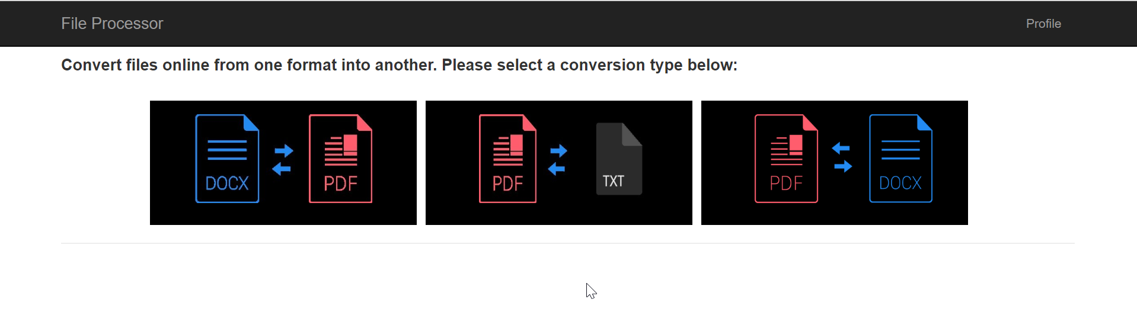

DOCX to PDF conversion view:

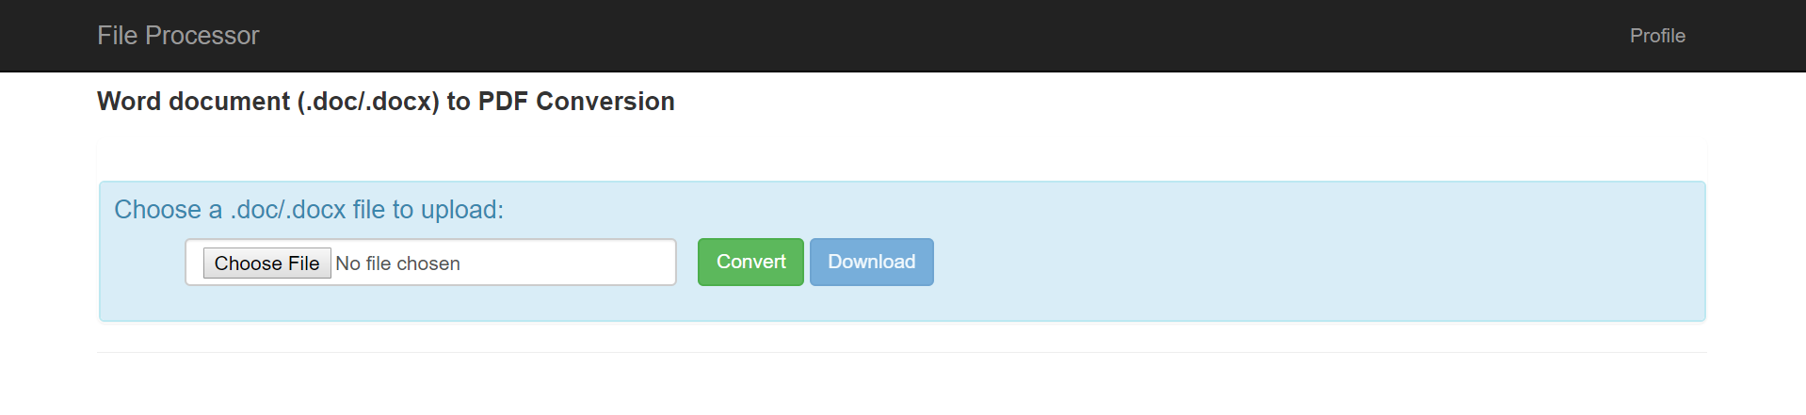

PDF to TXT conversion view:

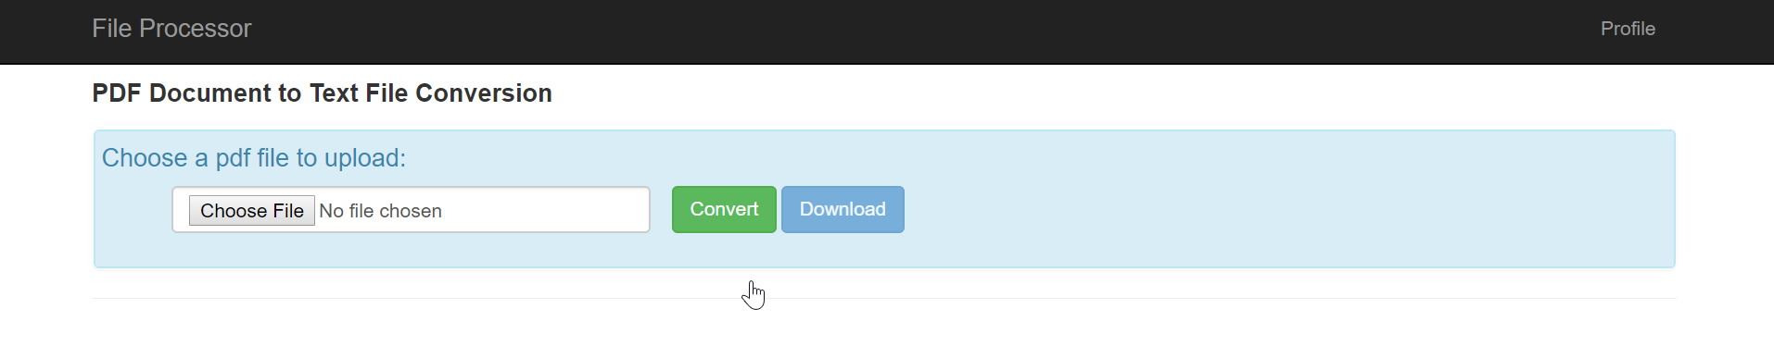

PDF to DOC/DOCX conversion view:

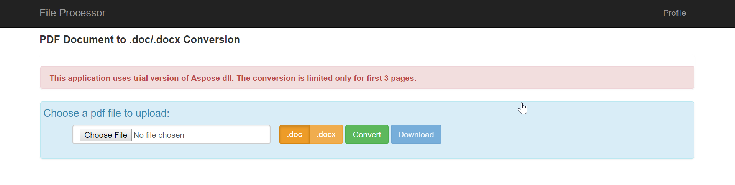

User Profile view:

